MuscleX Reports

This document is regrouping all the tests made concerning the speed, coverage and memory usage of MuscleX. Tests have been made under Python 3.8 with MuscleX v1.21.

# Memory usage reports

**To use memory profiler:**

**mprof run musclex qf**

**To display the result:**

**mprof plot**

**To have the details, run:**

**python -m memory_profiler example.py**

The image tested is 39MB (uncompressed):

data/EIGERtestdatacardiac/P2_F5_849_1_094_data_000001_0001.tif

The H5 tested is 216MB :

data/EIGERtestdatacardiac/h5/P2_F5_849_1_094_data_000001.h5

An H5 file is compressed, but its true size is 4000MB (h5dump -pH).

In the reports, the graphs are in MiB, and 1 MiB is equal to 1.05 MB.

## X-Ray Viewer

Tested on a TIF image:

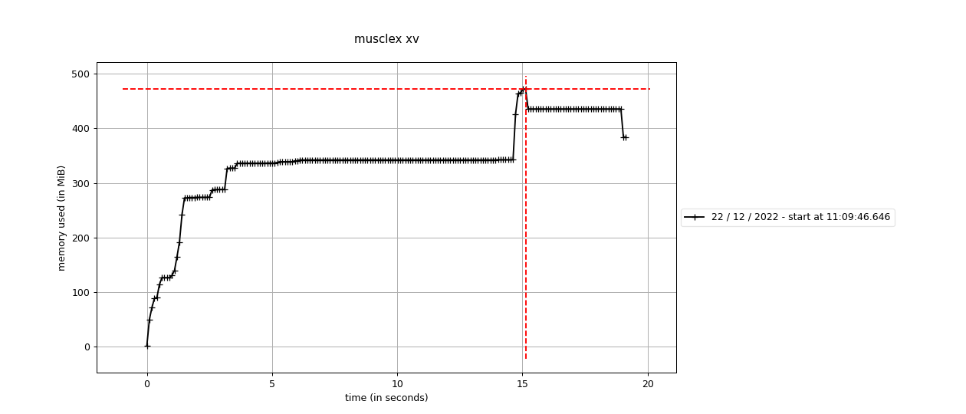

X-Ray viewer gives us a good idea of how much the program costs by itself (without any processing). The base usage is 380MB (Python, Qt5) and with the image (40MB).

## Equator

Memory multiplier = (2000 - 600)/40 = 35

The baseline with the added modules is 600MB (400MB before the other modules)

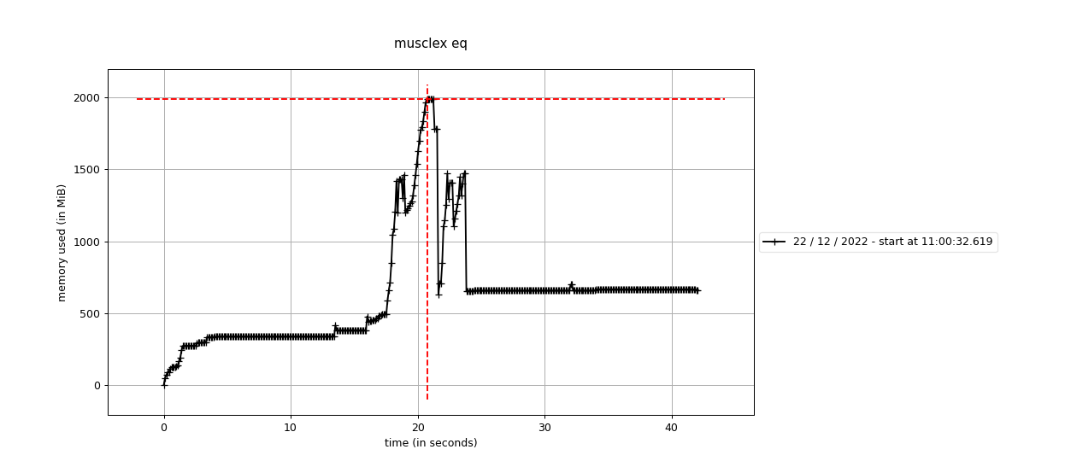

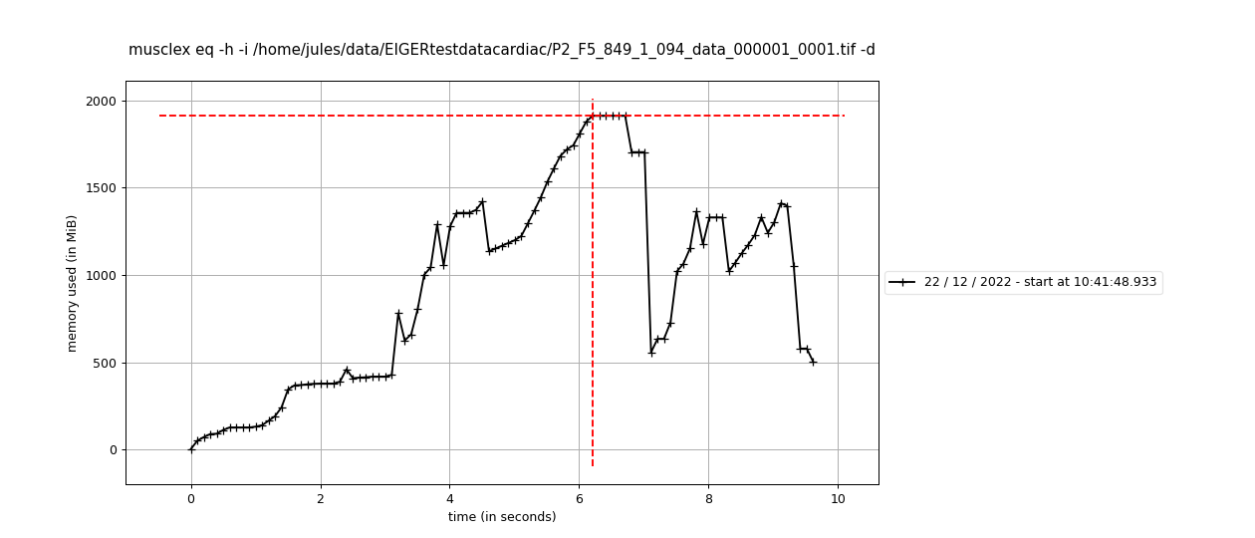

## 

GUI (top) and Headless (bottom) give a similar result: around 2GB at the peak which is happening during rotationAngle.

## Quadrant Folder

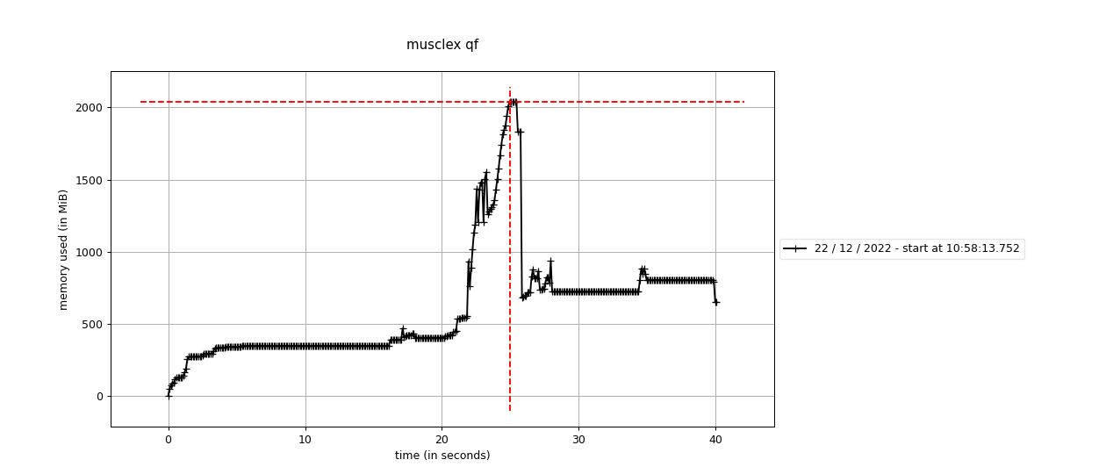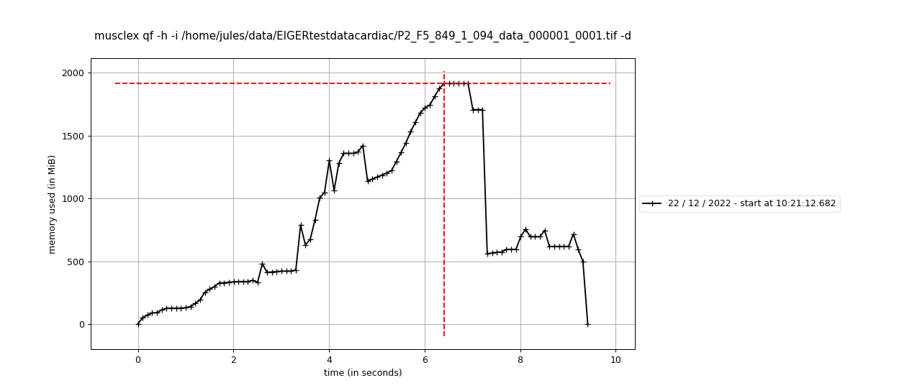

GUI (top) and Headless (bottom) give a similar result: around 2GB at the peak which is happening during rotationAngle.

Memory leak test on QF:

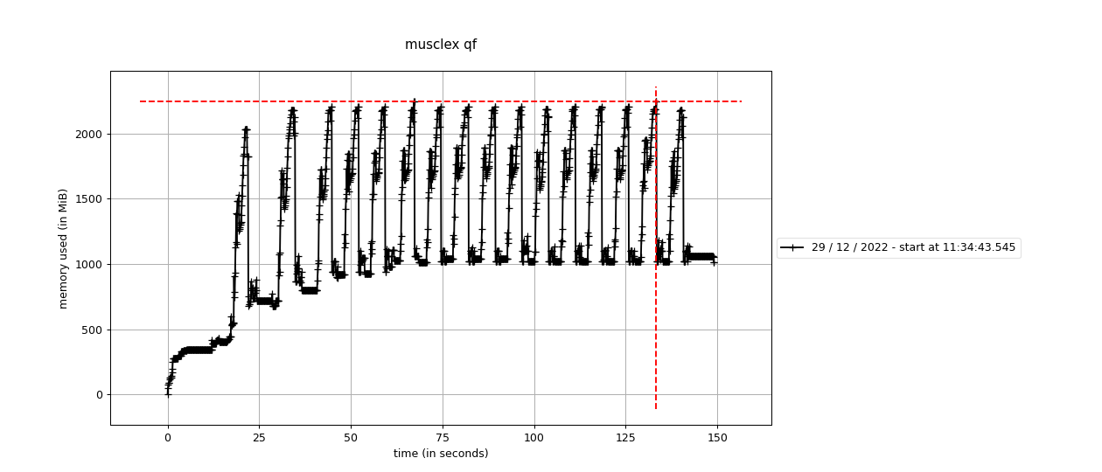

We can see that the memory is rising over the first 2 or 3 images before being stable.

## Scanning Diffraction

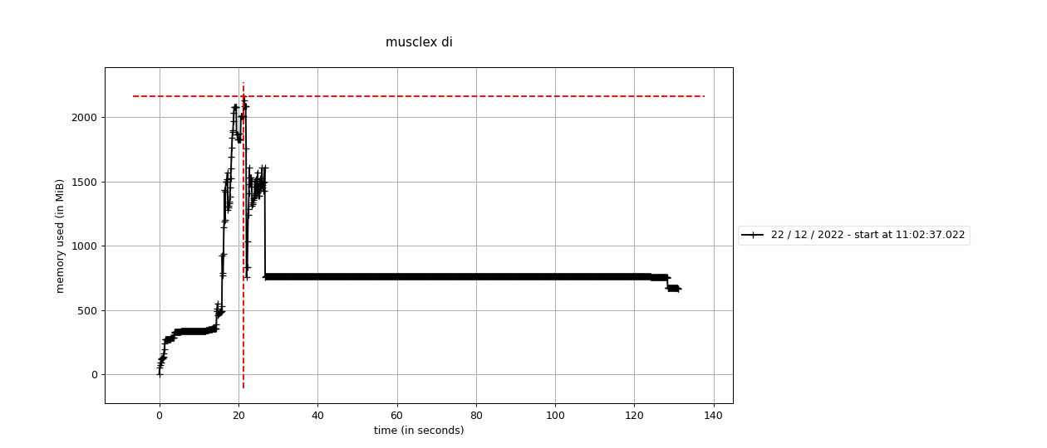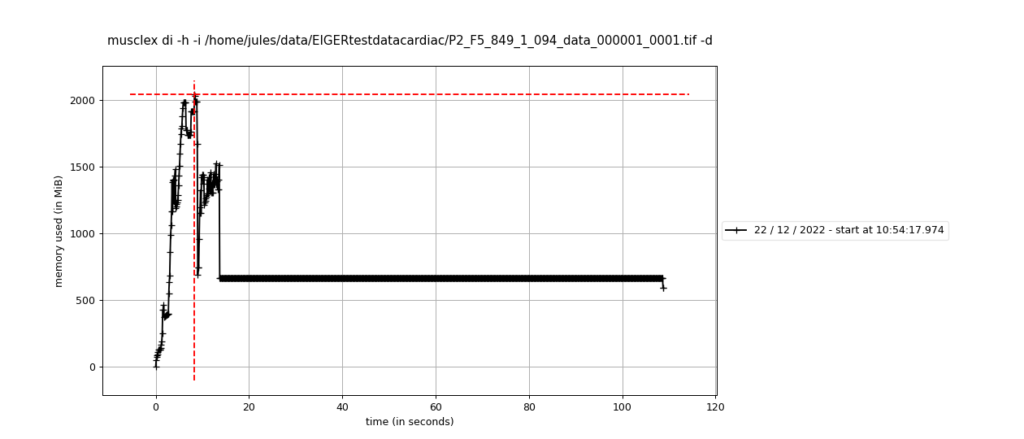

GUI (top) and Headless (bottom) give a similar result: around 2GB at the peak. There is a long and constant processing time in this function (more than 80 seconds). It is due to lmfit. Fixing the maximum number of function evaluations should fit this problem.

## Diffraction Centroids

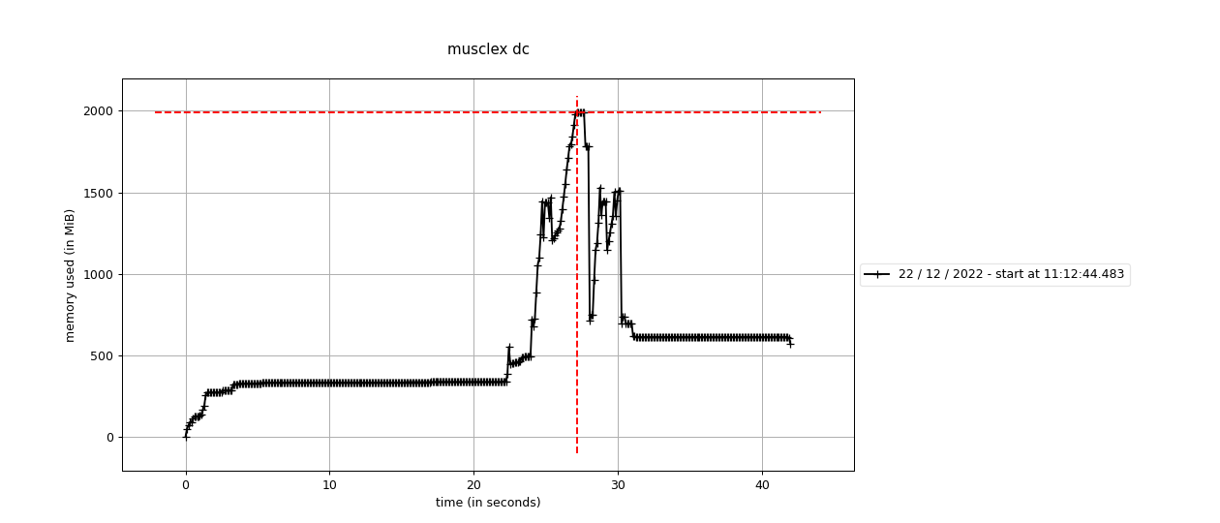

Peak at around 2GB.

## Projection Traces

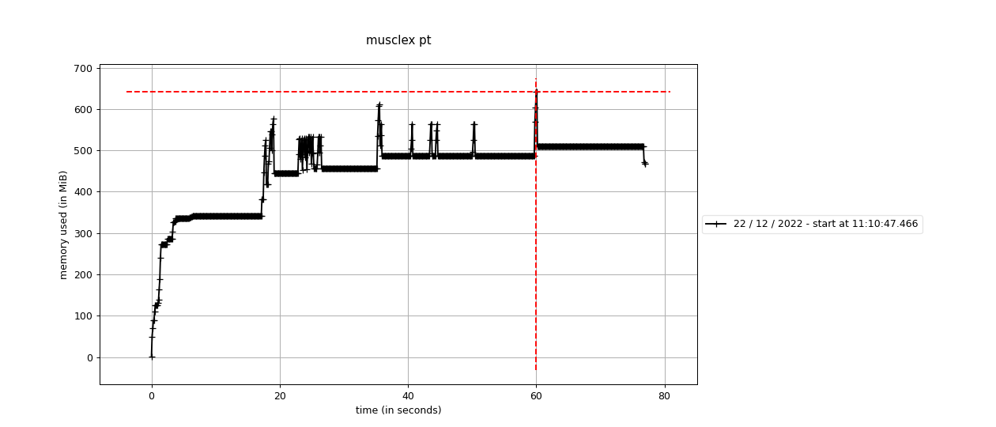

No noticeable peak.

## Add Intensities Single Experiment

AISE on a folder of TIFF images:

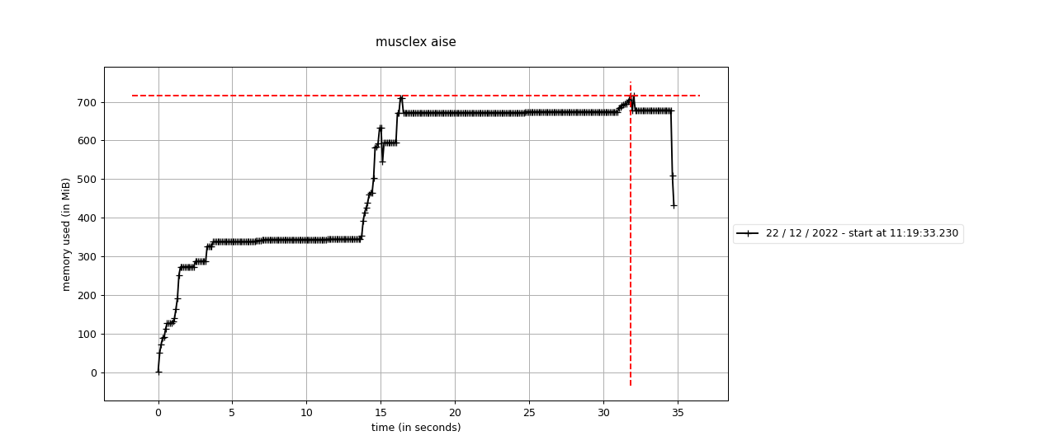

AISE on an h5 file:

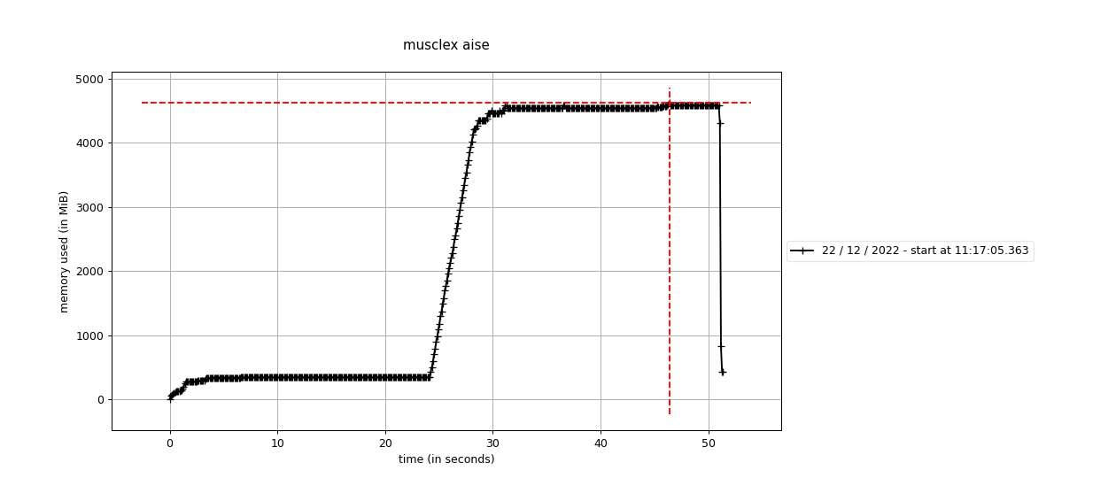

We can see that the h5 files make the process use a lot more memory. Indeed, opening an h5 file opens all the images inside of it, making it very memory consuming. Maybe we need to look at how to open a smaller group of images at the same time.

## Add Intensities Multiple Experiments

AIME on a folder of TIF images:

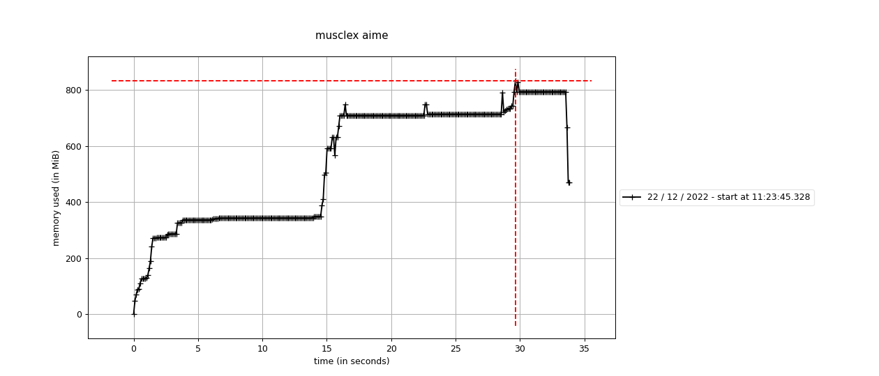

AIME on a folder of h5 files:

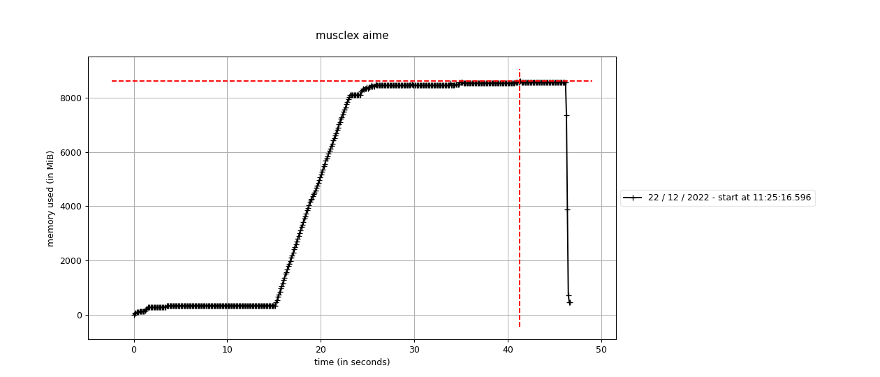

We can see that the h5 files make the process use a lot more memory. Indeed, opening an h5 file opens all the images inside of it, making it very memory consuming. Maybe we need to look at how to open a smaller group of images at the same time.

This has been fixed by opening groups of images instead of the whole file, as well as memory leak on AIME and AISE by using garbage collector.

# Calls reports

**To profile calls, add in main.py by replacing what is in *if __name__ == “__main__”* by:**

import cProfile

cProfile.run('main(sys.argv)', 'output.dat')

import pstats

from pstats import SortKey

with open('output_time.txt', 'w') as f:

p = pstats.Stats('output.dat', stream=f)

p.sort_stats('time').print_stats()

with open('output_calls.txt', 'w') as f:

p = pstats.Stats('output.dat', stream=f)

p.sort_stats('calls').print_stats()

**Run the program:**

**python main.py di -h -i ~/data/EIGER_testImages/17ER_190_data_000001_0001.tif -d**

This part was only tested on Headless programs (EQ, QF, DI).

## Equator Headless

Tue Jan 3 09:52:51 2023 output.dat

249273 function calls (243394 primitive calls) in 13.156 seconds

**Ordered by: internal time**

ncalls tottime percall cumtime percall filename:lineno(function)

2 4.296 2.148 8.474 4.237 /home/jules/Documents/venv/mmusclex_git/lib/python3.8/site-packages/pyFAI/azimuthalIntegrator.py:447(setup_CSR)

2 1.732 0.866 1.732 0.866 {morphologyEx}

3 1.084 0.361 1.340 0.447 /home/jules/Documents/venv/mmusclex_git/lib/python3.8/site-packages/pyFAI/geometry.py:703(corner_array)

697 0.925 0.001 0.925 0.001 {method 'reduce' of 'numpy.ufunc' objects}

**Ordered by: call count**

ncalls tottime percall cumtime percall filename:lineno(function)

25215/24933 0.002 0.000 0.003 0.000 {built-in method builtins.len}

20565/20535 0.003 0.000 0.004 0.000 {built-in method builtins.isinstance}

17018 0.002 0.000 0.002 0.000 {method 'append' of 'list' objects}

16031 0.004 0.000 0.005 0.000 /home/jules/Documents/venv/mmusclex_git/lib/python3.8/site-packages/lmfit/model.py:788(_strip_prefix)

The slow functions are part of pyFAI so there is not much to do to improve it.

## Quadrant Folder Headless

Tue Jan 3 09:54:20 2023 output.dat

2144340 function calls (2034956 primitive calls) in 12.461 seconds

**Ordered by: internal time**

ncalls tottime percall cumtime percall filename:lineno(function)

2 3.421 1.711 6.653 3.326 /home/jules/Documents/venv/mmusclex_git/lib/python3.8/site-packages/pyFAI/azimuthalIntegrator.py:447(setup_CSR)

2 1.674 0.837 1.674 0.837 {morphologyEx}

2 0.952 0.476 0.952 0.476 /home/jules/Documents/venv/mmusclex_git/lib/python3.8/site-packages/pyFAI/geometry.py:965(deltaChi)

4 0.650 0.162 0.807 0.202 /home/jules/Documents/venv/mmusclex_git/lib/python3.8/site-packages/pyFAI/geometry.py:703(corner_array)

**Ordered by: call count**

ncalls tottime percall cumtime percall filename:lineno(function)

311183/311156 0.033 0.000 0.045 0.000 {built-in method builtins.isinstance}

58719/57514 0.006 0.000 0.006 0.000 {built-in method builtins.len}

56686/56582 0.012 0.000 0.022 0.000 {built-in method builtins.getattr}

48356/8757 0.037 0.000 0.053 0.000 /home/jules/Documents/venv/mmusclex_git/lib/python3.8/site-packages/numba/core/ir.py:313(_rec_list_vars)

The slow functions are part of pyFAI so there is not much to do to improve it.

## Scanning Diffraction Headless

Tue Jan 3 09:50:55 2023 output.dat

1225196 function calls (1190840 primitive calls) in 23.029 seconds

**Ordered by: internal time**

ncalls tottime percall cumtime percall filename:lineno(function)

10 6.705 0.670 12.305 1.230 /home/jules/Documents/venv/mmusclex_git/lib/python3.8/site-packages/pyFAI/azimuthalIntegrator.py:447(setup_CSR)

10 2.981 0.298 9.318 0.932 /home/jules/Documents/venv/mmusclex_git/lib/python3.8/site-packages/pyFAI/azimuthalIntegrator.py:1099(integrate1d_ng)

9 1.651 0.183 1.651 0.183 /home/jules/Documents/venv/mmusclex_git/lib/python3.8/site-packages/pyFAI/geometry.py:965(deltaChi)

1 1.435 1.435 1.474 1.474 /home/jules/Documents/venv/mmusclex_git/lib/python3.8/site-packages/musclex-1.21.0-py3.8.egg/musclex/modules/ScanningDiffraction.py:511(get_runs_from_image)

**Ordered by: call count**

ncalls tottime percall cumtime percall filename:lineno(function)

174445/174257 0.012 0.000 0.012 0.000 {built-in method builtins.len}

126329 0.040 0.000 0.059 0.000 /home/jules/Documents/venv/mmusclex_git/lib/python3.8/site-packages/lmfit/model.py:788(_strip_prefix)

108397/108367 0.012 0.000 0.015 0.000 {built-in method builtins.isinstance}

100291 0.012 0.000 0.012 0.000 {method 'startswith' of 'str' objects}

The slow functions are part of pyFAI so there is not much to do to improve it.

# Coverage reports

**To use coverage.py:**

**coverage run -m main test_global**

**To generate the file:**

**coverage html -i**

This part gives a summary of the coverage of the whole program, but it is using “test_global”, which is running consistency tests but only on Equator, Quadrant Folder and Scanning Diffraction.

On lethocerus:

file:///home/jules/Documents/musclex_reports/coverage_musclex/htmlcov/index.html

# CPU Usage

Run: **htop**

Run MuscleX

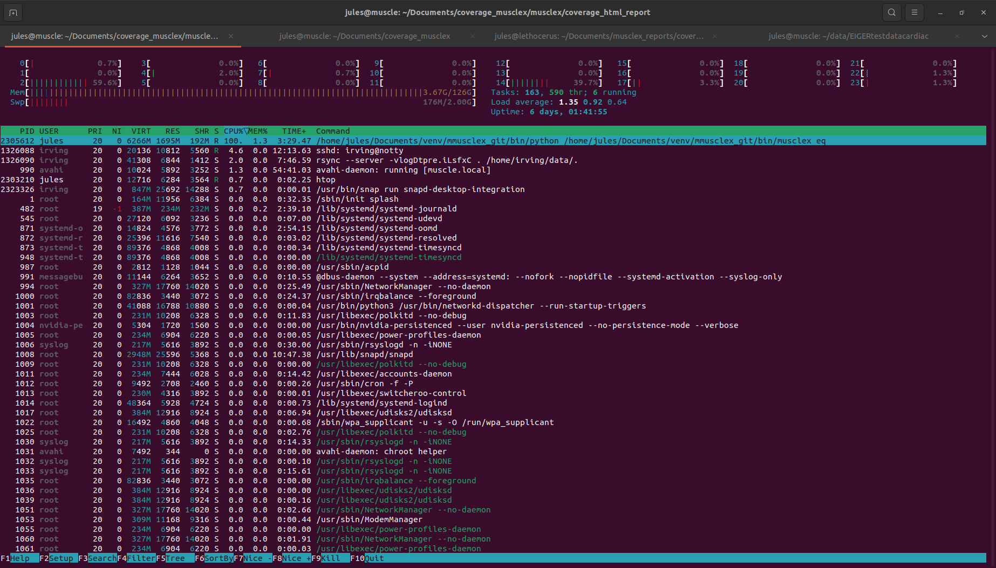

100% of the CPU used when musclex eq is running for example.

*Jules N., 12/28/2022*